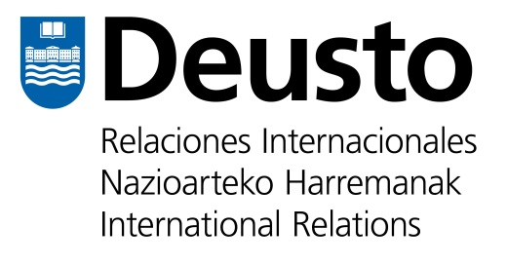

QUESTIONNAIRE FOR STAFF TRAINING MOBILITIES TO THE UNIVERSITY OF DEUSTO
ERASMUS+ KA 107 PROGRAM

Dear Erasmus+ KA107 applicant,
In order to have a better understanding of your application to the Staff Training Program at the University of Deusto, please fill in the below questionnaire and include it with the rest of your application documents:
- Mobility Agreement
- Curriculum Vitae
- Passport
- Letter of support from supervisor at your home university

Please remember to send ALL documents by the deadline of the call for applications: JANUARY, 20TH 2017

PART 1: We want to know more about you

I.1 Please describe your Job position

I.2 Please indicate your professional experience dealing with the following programs. Use as much writing space as necessary.
a) Erasmus Mundus. Please describe
b) International Programs. Please describe
c) Joint Cooperation programs. Please describe
d) Any grant programme. Please describe
e) International Research. Please describe

PART2: About your university

II.1 Please indicate the academic offer of your University in English? Include Faculties whose offer is fully or partially in English.

II.2 Which UNDERGRADUATE programmes do you have in English or partially in English (at least one academic year)?

II.3 Which of your MASTER programmes on offer is in English?

Please fill in the following

NAME OF THE APPLICANT:

HOME UNIVERSITY:

DATE AND SIGNATURE:

Thank you very much and best of luck with the selection process!

Regards,
International Projects Area from the University of Deusto

